**Group Assignment 8**

**Online Hotel Reservation App Information Architecture**

**（全他娘的在装尸体，四个人的组三具尸体，这是老子一个人写的）**



# Topic

Our topic for the project is a Hotel reservation app. This is a cloud-based property management system designed to meet the needs of hospitality businesses of all sizes including hotels, motels, resorts, B&Bs, lodges and campgrounds. It also provides tools to help users manage hospitality businesses.

The app provides a customized booking engine that matches the look and feel of a property’s website. Its property management system lets staff handle day-to-day operations. Checking guests in and out, managing which rooms are clean or dirty for housekeeping, and running customized reports are all supported.

# Overview

We are intended to create an Information Architecture for our project topic using open and closed card sorting. Then withdraw the differences between the 2 approaches.

# Persona

|  |  |
| --- | --- |
| Name | Jimmy Hart |
| Age | 37 |
| Occupation | Manager of Baseball League |
| Technical Profile | Average attitude towards ecommerce site |
| Family | Divorced , has 4 children |
| Household Income | $300,000/y |
| Internet use | Half for daily news, half for shopping online |
| Favorite Sites | BBC, CNN, Airbnb, Costco |
| Role in the app | Customer |

Heuristics

A heuristic is a mental shortcut that allows people to solve problems and make judgments quickly and efficiently. These rule-of-thumb strategies shorten decision-making time and allow people to function without constantly stopping to think about their next course of action. Heuristics are helpful in many situations, but they can also lead to cognitive biases.

Being aware of how heuristics work as well as the potential biases they introduce might help you make better and more accurate decisions.

Heuristics play important roles in both problem-solving and decision-making, as we often turn to these mental shortcuts when we need a quick solution.

|  |  |  |  |  |  |  |  |  |  |
| --- | --- | --- | --- | --- | --- | --- | --- | --- | --- |
| **Site Name: Airbnb APP** | **/User**  **Homepage** | **/SignIn System** | **/Review System** | **/Home**  **menu** | **/Homemenu/**  **HouseHolder-menu** | **/Homemenu/Seller-menu/**  **Property-panel** | **/Search-Item** | **/Shopping-cart** | **/Shopping-cart/**  **Place-order** |
| **Heuristic** | **Score** | **Score** | Score | Score | Score | Score | Score | Score | Score |
| **Clear** | Minor Problem | Meets Best Practice | Meets Best Practice | Meets Best Practice | Meets Best Practice | Meets Best Practice | Meets Best Practice | Meets Best Practice | Meets Best Practice |
| **Communicative** | Meets Best Practice | Minor Problem | Meets Best Practice | Meets Best Practice | Meets Best Practice | Meets Best Practice | Meets Best Practice | Meets Best Practice | Meets Best Practice |
| **Usable** | Meets Best Practice | Meets Best Practice | Meets Best Practice | Minor Problem | Meets Best Practice | Meets Best Practice | Meets Best Practice | Meets Best Practice | Meets Best Practice |
| **Credibility** | Meets Best Practice | Meets Best Practice | N/A | Meets Best Practice | Medium Problem | Meets Best Practice | Meets Best Practice | Meets Best Practice | Minor Problem |
| **Controllable** | Meets Best Practice | Meets Best Practice | Meets Best Practice | Meets Best Practice | Meets Best Practice | Minor Problem | Meets Best Practice | N/A | Meets Best Practice |
| **Valuable** | N/A | Meets Best Practice | Meets Best Practice | Meets Best Practice | Meets Best Practice | Meets Best Practice | Meets Best Practice | Minor Problem | Meets Best Practice |
| **Learnable** | Meets Best Practice | Meets Best Practice | Meets Best Practice | N/A | Meets Best Practice | Minor Problem | Meets Best Practice | Meets Best Practice | Minor Problem |
| **Delightful** | Meets Best Practice | Meets Best Practice | Meets Best Practice | Meets Best Practice | Minor Problem | Meets Best Practice | Meets Best Practice | Meets Best Practice | N/A |

# Initial Sitemap

Card Sort

Definition:

Card sorting is a method used to help design or evaluate the information architecture of a site. In a card sorting session, participants organize topics into categories that make sense to them and they may also help you label these groups.

# **How to conduct a card sorting session?**

## **Step 1: Make cards**

* For a new site, list the content topics of types of information that you are likely to have.
* For an existing site, list the most important types of content.

## **Step 2: Ask your users to group the cards**

* Allow users to add new cards or put some cards aside.
* If there are too many groups, ask users to combine some of them.
* Ask users to give a name for each category

## **Step 3: Thank your participants and give them a hug/candy/gift :p**

## **Step 4: Analyze your results**

* Analyze qualitative information based on user comments.
* Analyze quantitative information based on: Which cards appeared together most often? How often cards appeared in specific categories?

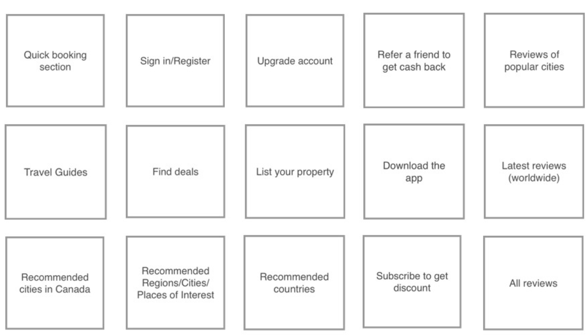

# Open Card Sort

* **Open Card Sort**: Participants are asked to organize topics from content within your website into groups that make sense to them and then name each group they created in a way that they feel accurately describes the content. Use an open card sort to learn how users group content and the terms or labels they give each category.

|  |  |  |  |
| --- | --- | --- | --- |
| **Participant 1:** | | | |
| Search Options | Review Options | Customer Service | App management |
| Quick booking section | Reviews of cities | Refer a friend to get cash back | Sign/Register |
| Find deals | Latest reviews(worldwide) | Travel guides | Upgrade app |
| Recommended cities in Canada | All reviews | List your property | Download the app |
| Recommended Regions/Cites/Places of interest |  | Subscribe to discount |  |
| Recommended countries |  |  |  |

# Closed Card Sort

* **Closed Card Sort**: Participants are asked to sort topics from content within your website into pre-defined categories. A closed card sort works best when you are working with a pre-defined set of categories, and you want to learn how users sort content items into each category.

|  |  |  |
| --- | --- | --- |
| **Participant 2:** | | |
| High Priority | Medium Priority | Low Priority |
| Quick booking section | Recommended cities in Canada | Upgrade app |
| Find deals | Recommended Regions/Cites/Places of interest | Download the app |
| Reviews of cities | Refer a friend to get cash back | Sign/Register |
| All reviews | List your property |  |
| Latest reviews(worldwide) | Subscribe to discount |  |
| Travel guides | Recommended countries |  |

Analysis

After analyzing the results of all our card sorting sessions, we’ll be in a much more informed position about the shape our IA should take and how best to structure the content hierarchy. Decide where to place content and what content needs to be changed. For instance, if many participants edited one card name (for example, style type to length), then include them in our final decision-making.

* Users are very concerned about user service system
* Compared with the user navigation part, participants pay more attention to the reviews.
* From the Customer side, Customer feed-back gets increasingly important and popular.

From those conclusions we draw, We can roughly know which parts customers are more interested in, so here I will provide several specific topics for participants and allow them to sort those cards based on the rules and limitations I set.

User Flow

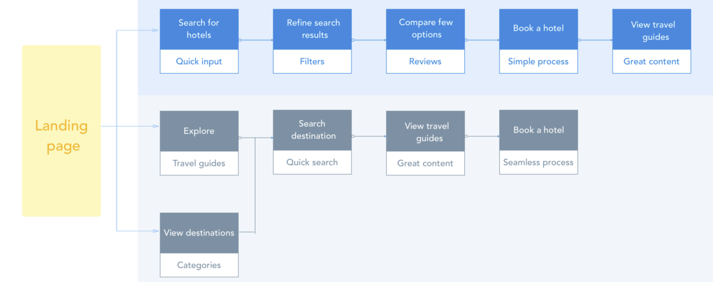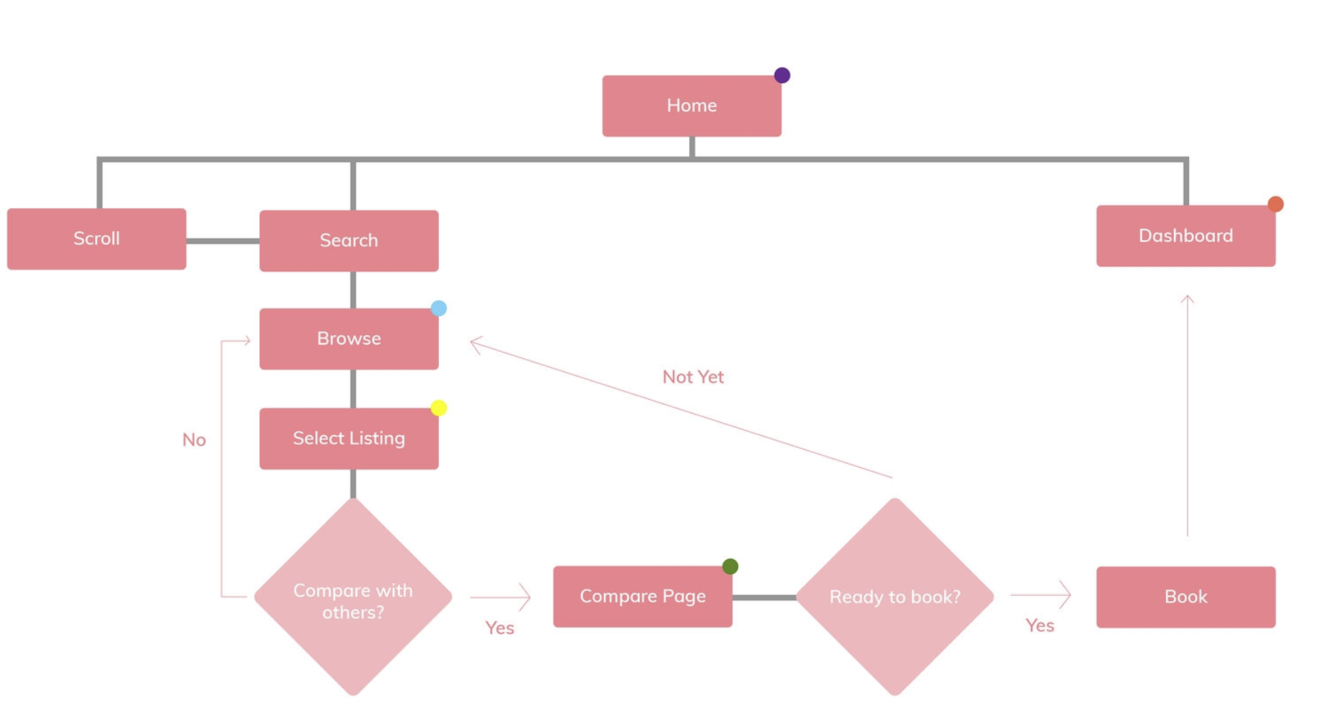

Revised Site Map

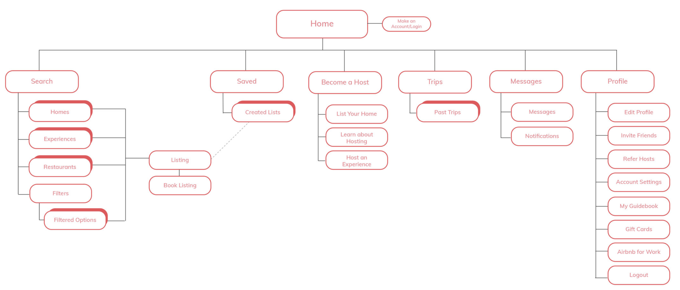

Reflection

Card sorting can help you decide what exactly to put on the homepage, for example, but also how to label categories and structure the navigation of your website.Although it’s not the solution to everything, it can indeed point you in the right direction. The trick to finding the perfect IA, is to test, analyze and test again! One of the great things about card sorting is that you can use it for both new and existing IAs.

# Difference between open and close card sorting

* Open card sorting is the most common type of card sort and what we described above. Generally, when practitioners use the term card sort, it’s implied that it will be an open card sort. In an open card sort, users are free to assign whatever names they want to the groups they’ve created with the cards in the stack.
* Closed card sorting is a variation where users are given a predetermined set of category names, and they are asked to organize the individual cards into these predetermined categories. Closed card sorting does not reveal how users conceptualize a set of topics. Instead, it is used to evaluate how well an existing category structure supports the content, from a user’s perspective. A critique of the closed card sort is that it tests users’ ability to fit the content into the “correct” bucket ­— to users, it can feel more like solving a puzzle than like naturally matching content to categories. The method does not reflect how users naturally browse content, which is to first scan categories and make a selection based on information scent. Instead of closed card sorting, we recommend tree testing (also known as reverse card sorting) as a way to evaluate navigation categories.